JULY 2019
Make a Note!

DATES FOR YOUR DIARY:

END OF SUMMER TERM  INSET DAY  START OF AUTUMN TERM  AUTUMN EVENING  AUTUMN HALF TERM  FAMILY PHOTOGRAHER  OPEN WEEK  NATIVITIES  CHRISTMAS PARTY (ALL CHILDREN INVITED. 8:45AM-11:45AM.)  END OF AUTUMN TERM – NURSERY CLOSES AT 11:45AM! | FRIDAY, 19th JULY  TUESDAY 3RD SEPTEMBER 2019  WEDNESDAY, 4th SEPTEMBER 2019  FRIDAY 25TH OCTOBER 2019  28th OCTOBER -1st NOVEMBER 2019  SATURDAY 26TH OCTOBER 2019  W/C 25TH NOVEMBER 2019  MONDAY 16TH DECEMBER 2019  FRIDAY 20TH DECEMBER 2019  FRIDAY 20TH DECEMBER 2019

Dear Parents
Well, this term has certainly flown past and it has been jammed packed with exciting events and activities. The children really enjoyed the Meadow Mayhem! We had a very good turnout and I would like to thank all the committee and parents who helped make it such a fantastic success.
This term, the children have enjoyed lots of exciting activities such as: splat painting, fizzing rainbows, bug hunts, treasure hunts and obstacle courses.

**COMMITTEE MEMBERS NEEDED!!**
Our AGM will be held next term. As a Charity, we have a legal obligation to have a full and functioning committee, otherwise we cannot open. It is also a wonderful opportunity for parents to get involved in their child’s education. Nobody is ever left unsupported to tackle any duties on their
own, there is a great sense of teamwork and it really can be lots of fun. The date for this very important meeting will be confirmed at the beginning of next term. Remember, this is YOUR Nursery - please think about volunteering for one
of the positions and try your very best to attend the meeting. We look forward to seeing you there.

GOODBYES – We would like to wish the following children all the very best in their new schools:
Hamish Barbour Ella Blowey
Sophie Bluett Jessica Chadwick
Bailey Clark Samuel Corse
Owen Dare Bertie Dinghile Maria Dinghile Chloe Dmonte
Isla Dron Reon Dsouza
Coast Durrant Kimberly Egwuagu Amina El Zayet Elissa Feist
Rosie Gibbs Samuel Guyot Max Hammond Casey Harrington
Riley Hawkins Rory Judd
Evie Higton Jenson Horrod
Melissa Kisieliauskaiter Miki Lanigan
Beatrice Lilley Martin Linhares
Archie Hinton Aaquil Mohamed Nofal
Beatrice Mohan Bridget Mohan
Dante Morgan Taran Nellies
Olivia Newman Charlie Peacock
Riley Prior Dhruv Rajani
Alfie Richardson Harry Ruengathits
Chloe Shaw Emma Soden
Wisdom Uwannah Divine Uwannah
Ava Watson Bella Woodward
Carwyn Bethencourt-Smith Ethan Douloubakas

LEAVING
We would also like to remind you that Miss Sue Chapman will be leaving us at the end of term. Miss Chapman has decided to spend some time pursuing other interests and is hanging up her tabard. Sue has been with us for 5 years; she was a one-one then an assistant and finally as a Level 2 qualified practitioner. Sue will be sorely missed, and we wish her all the best in whatever she does. If you would like to contribute towards a leaving gift, please hand labeled donations to Miss Hill (or any other member of staff except Miss Chapman!).

PICNIC – We are all looking forward to the picnic at Dinton Pastures on Friday 19th July. See you there!

A FEW REMINDERS:
JEWELLERY – Please could you make sure that your child does not come to Nursery wearing jewellery, as this can cause safety issues.
CROCS – We would like to remind you that crocs and flip flops are not appropriate footwear for Nursery.
SICKNESS – If your child has been unwell with sickness or diarrhoea, please keep them off school for at least 48 hours after the last episode. In the case of conjunctivitis, children can return to school 48hrs after their medication has started.
PARKING – Could all parents please be very careful when parking on Murray Road or Meadow Road. There have recently been several complaints from residents whose drive-ways have been partially blocked through inconsiderate parking. In addition, please DO NOT PARK IN THE ENTRANCE or any area adjacent to the entrance to Westoak Nursing Home. This includes using it as a turning place.

*VERY IMPORTANT*
May I please remind parents to shut the Nursery gate after entering or leaving the premises. We have had several incidents where younger siblings have left the garden whilst parents are queuing to collect or drop off their children. Please hold on to your children – they are your responsibility at these times. It only takes a second for a child to go astray and we would hate for anything to happen to them.
For Health and Safety reasons, please DO NOT allow your children to climb on the Nursery play equipment or railings outside. We take no responsibility for your child out of Nursery hours.
Have a wonderful summer break!

Debbie Hill
Nursery Manager
*REMINDER*
Our Policy Documents, Ofsted Report, audit and Risk Assessments can be viewed at any time. These can be found near the Nursery entrance on the left hand Art unit as you come in. If you are unsure, please ask a member of staff. These documents are also available to view online on our website. If you have any positive or negative feedback we are always pleased to hear from you. For any questions or queries, please contact either of the following: Mrs Jo Hargreaves – Chairperson Miss Debbie Hill – Manager

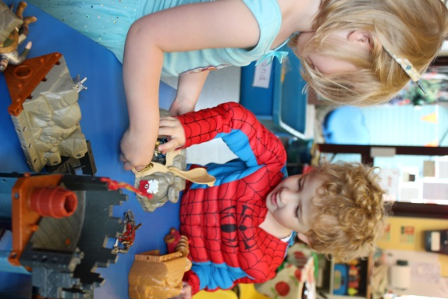
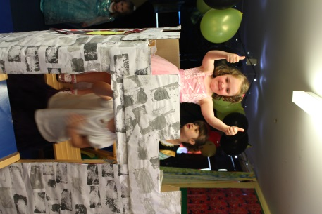
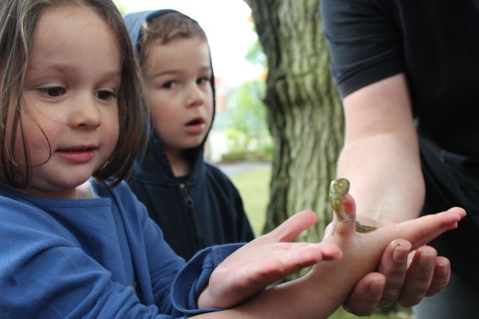
Enjoying the Princess, Knight and Superhero Week!
The children were fascinated by a large slug we found in the garden.

